**Day 20 Assignment - Vamsi Viswanadham**

**27/12/2023**

**Worked On Below Programs:**

* **How to Create a DataFrame:**

Create a dataframe using CreateDataFrame function as shown below:

Here we have used this function in the line:

df = **spark.createDataFrame**([(date,) for date in dates], schema=schema)

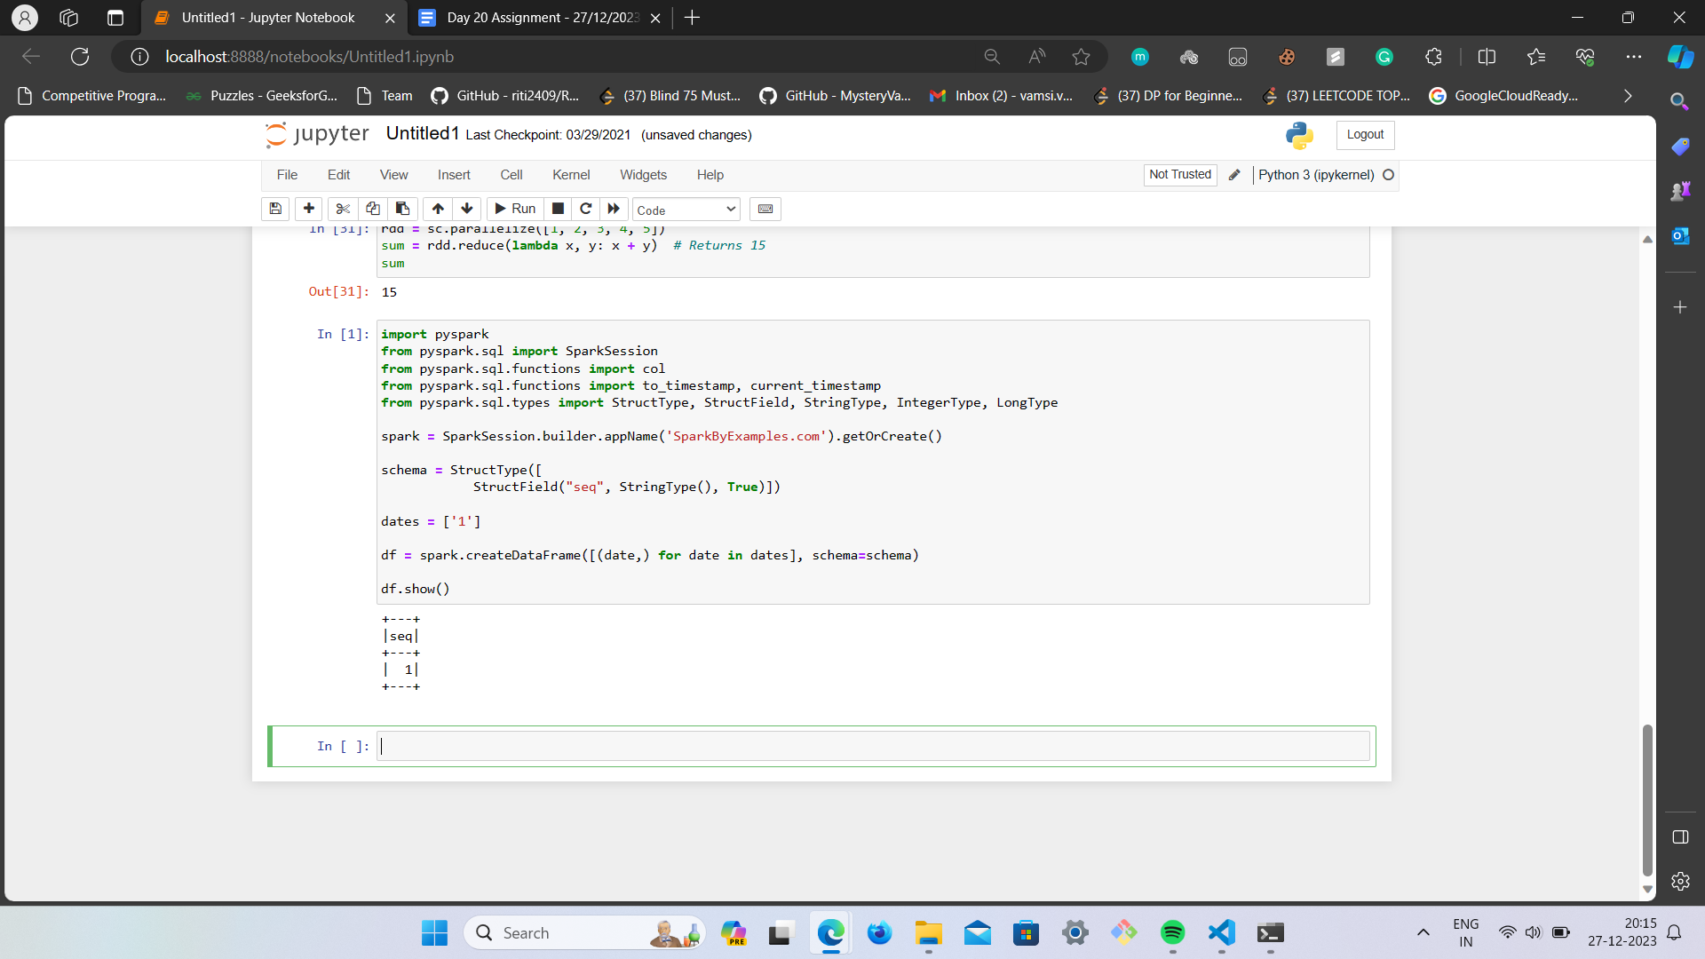

* **Creating a RDD using list of Rows. Here is a simple example for that:**

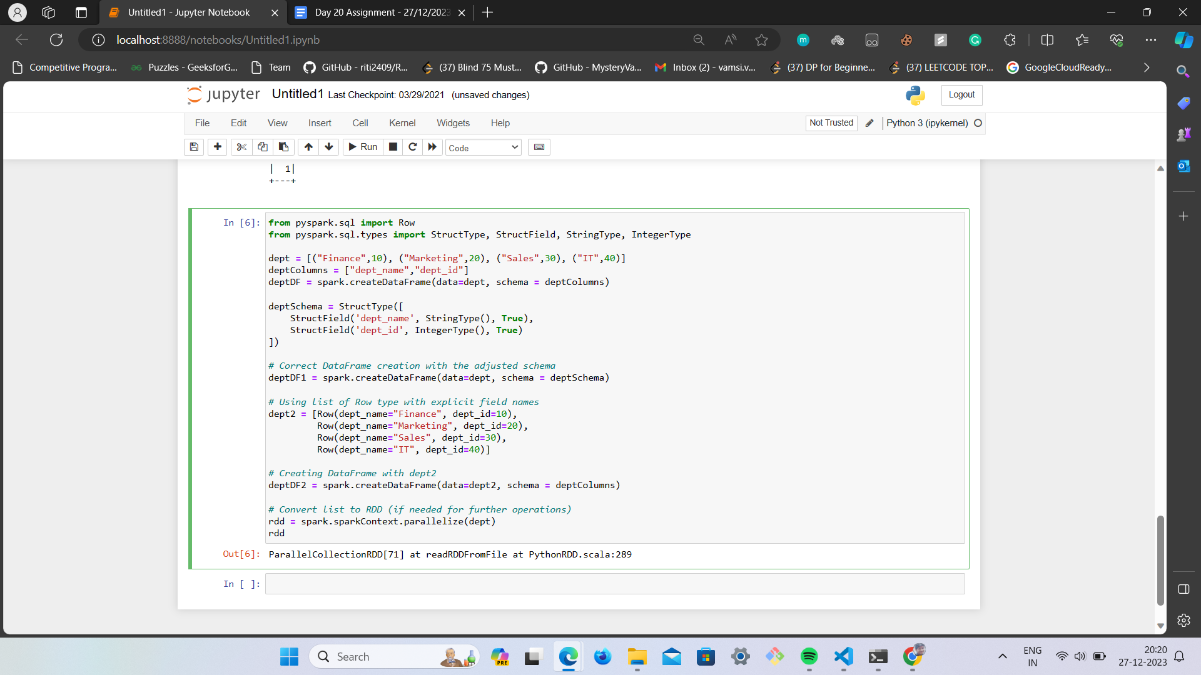

* **Selecting the data in string format using pyspark sql:**

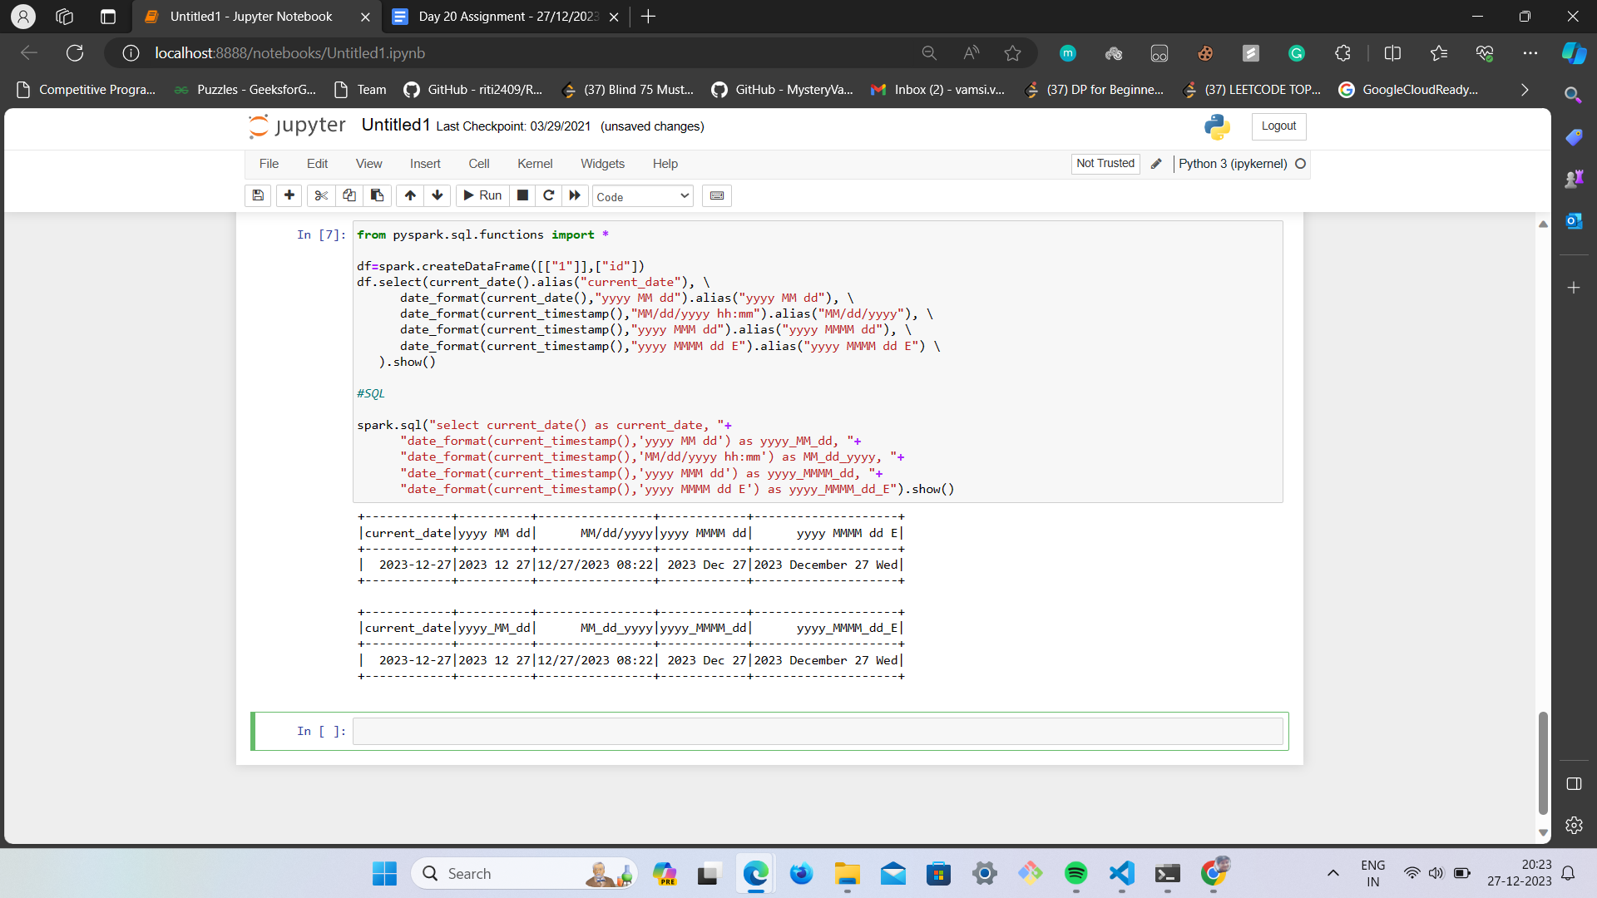

* PySpark Types available are listed below:

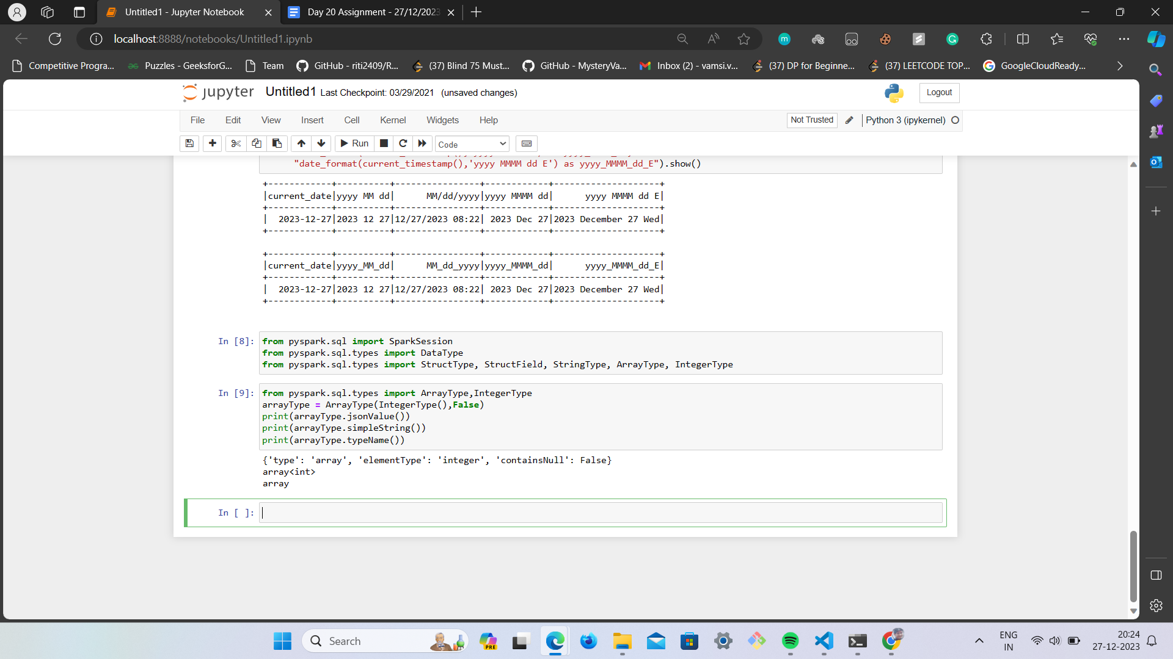

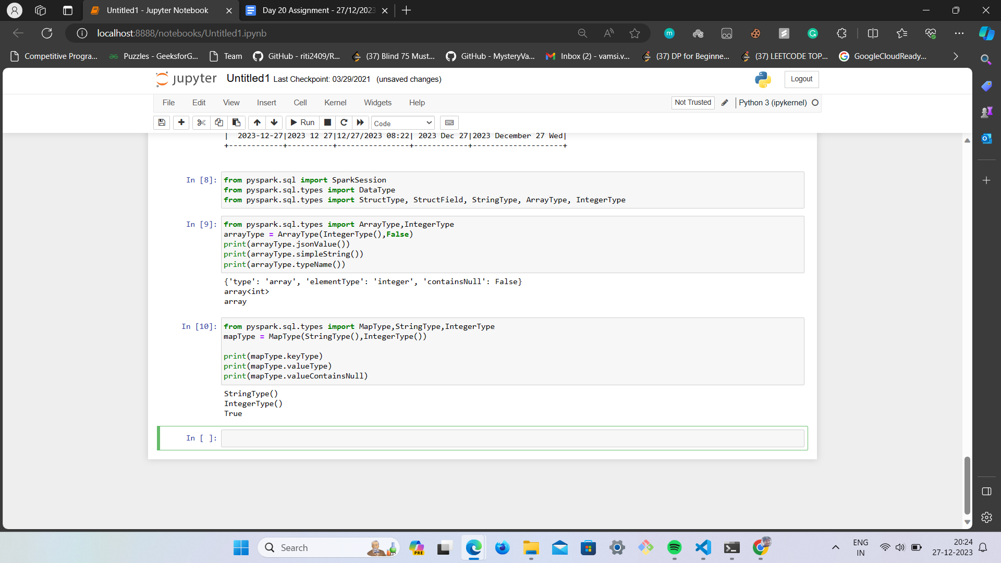

Examples of using Available Pyspark Types:

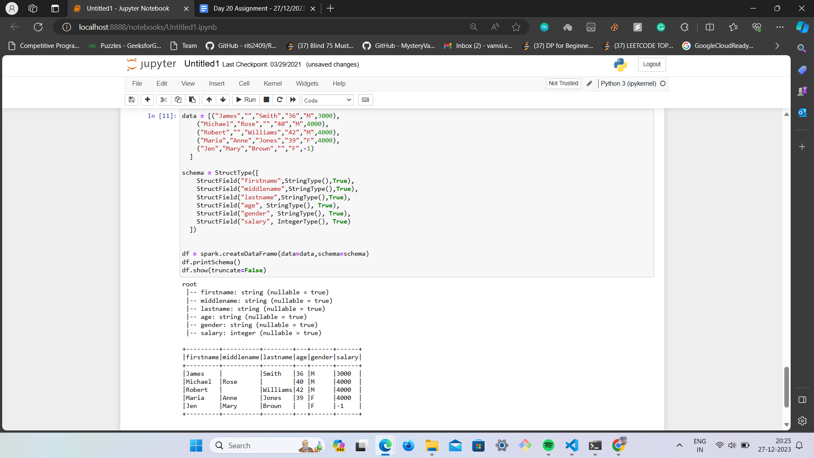

* Using PySpark Schema:

